Table of Contents

**Summary ………………………………………………………………………………………………………………………………2**

**Description** ……………………………………………………………………………………………………………………………….**2**

**Operating instructions** ………………………………………………………………………………………………………….….**3**

Add Events to Calendar …………………………………………………………………………………………………… .3

Add a Video to a Page …………………………..……………………………………………………………………….….6

Adjusting Waiting List ………………….……….……………………………………………………………………….….6

Edit Day Care Status ………………………………………………………………………………………………………….6

Edit Hours of Operation……………………………………………………………………………………………………..6

Editing page content………………………………………………………………………………………………………… 6

**Troubleshooting Techniques** ……………………………………………………………………………………………………**4**

**Summary**

**Description**

The new South End Community Day Care website was created as a visual and functional update to the previous website. The website was created using Wordpress which is content management system allowing for the client to easily navigate, edit and update the newly implemented features. Important features that the client requested was online wait-listing, events calendar, video plug-in, parallax layout, and a Day Care status section. The aim of the User Manual is to help guide the client through the different features as well as to reference in the future.

**Instructions**

1. **Add Events to Calendar**

Log into the website at <http://outreach.cs.dal.ca/daycare/wp-login.php>

**Events Calendar:**

The Event Calendar feature displays events in a calendar format as shown if figure 1.1. Which allows for easy sharing of events. This feature can also be displayed on the (sidebar) right hand side of the page, in text format that can direct the visitor to the calendar format.

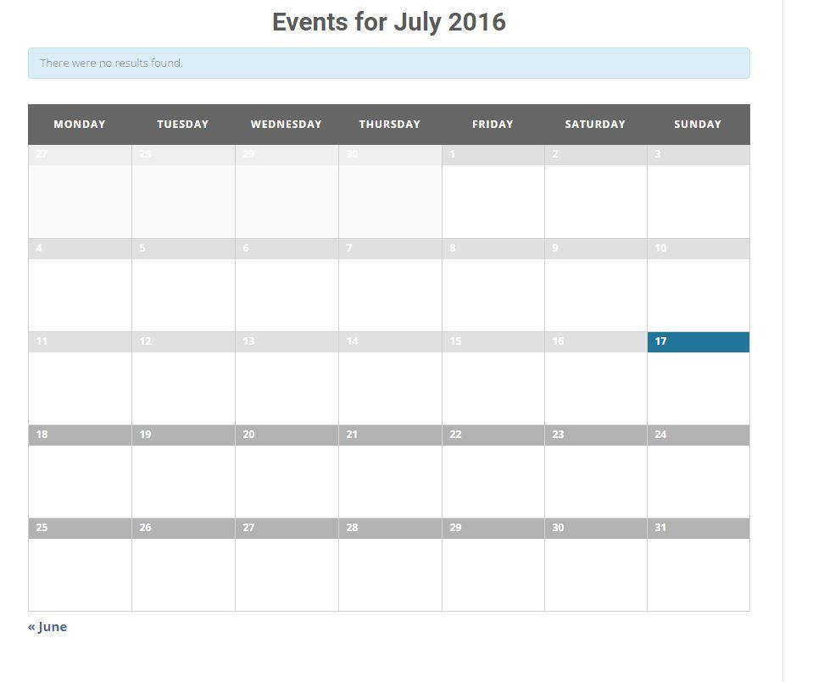

*figure 1.1:* A view of event list in calendar format.

**Administration:**

Follow the steps below to make changes to the Events Calendar feature:

**Adding an event:**

1- On the main administration panel on WordPress as shown in figure 1.2, click on ‘Events” found in the left side Menu bar.

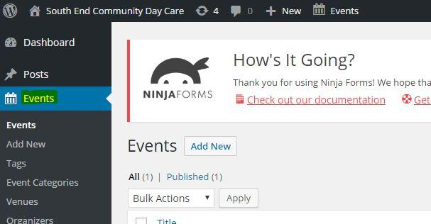

*figure 1.2:* WordPress dashboard having option of managing events.

2- On the Events administration page. select the “Add New” Button located near the “Events” title as shown in figure 1.3.

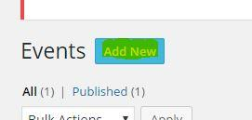

*figure 1.3:* Button highlighted used to add new events.

3- In the Panel shown in figure 1.4, input all the text field area’s that you would like to include for the event including and not limited to title, and event detail. The title area has the following text “Enter title here”. The event detail section is the large text field area directly below the title section.

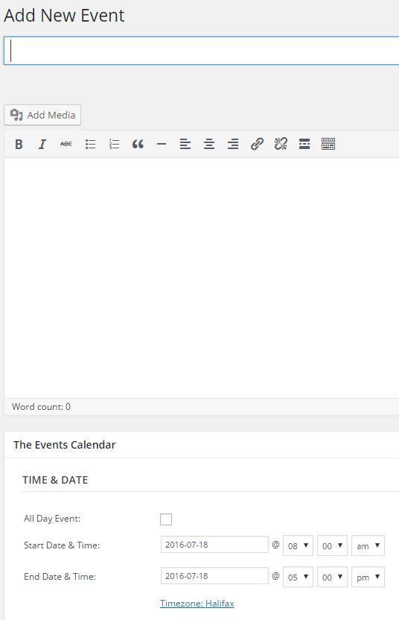

*figure 1.4:* basic description and text fields required to add new event.

4- For adding media files, such as a picture, video, music (mp3). Select the “Add Media” Button found below the title text field as shown in figure 1.5. Once there click the button “Select Files” in the center of the page as shown in figure 1.6, and select a local media file. Once complete select “Insert into Post” button at the right bottom of the page. Doing this will place the media file in the event description.

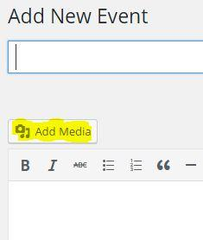

*figure 1.5:* Option for adding a media file.

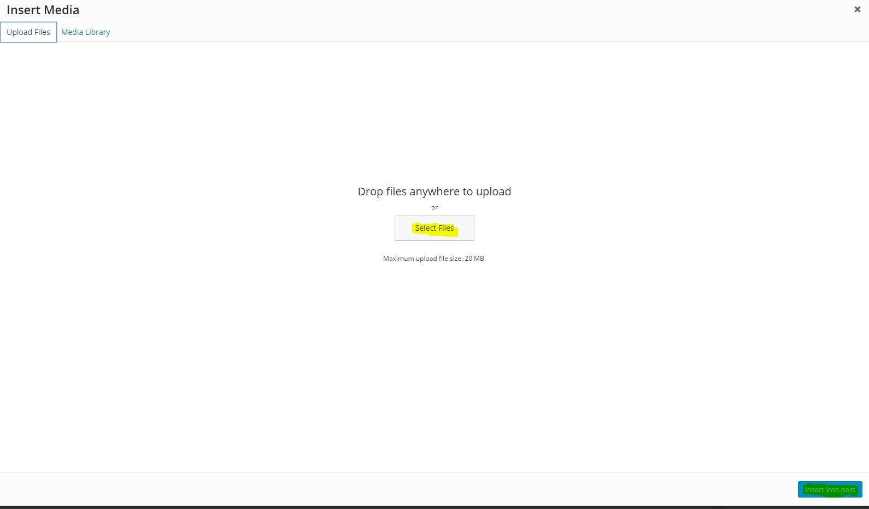 *figure 1.6:* Selecting a media file from Computer.

5- To add more details about the event such as time, date, location, and event organizer. Scroll down the page and various sections are bolded with the specific headings as shown in figure 1.7.

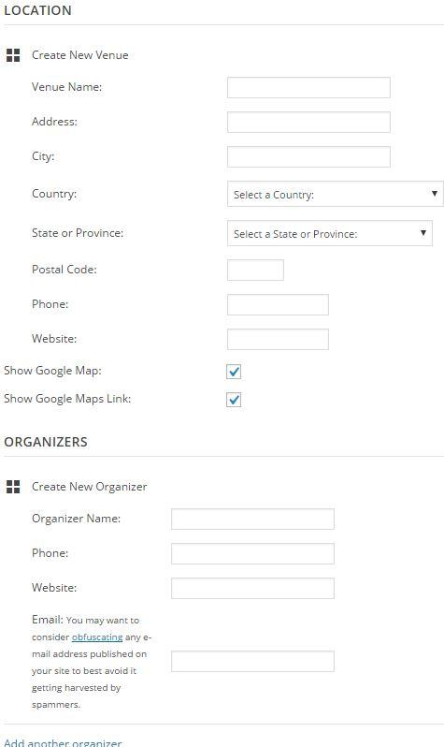

*figure 1.7:* Each field relate to description of an event.

6- Once you are complete with personalizing the event. Select the “Publish” button. At the right top side of the page as shown in figure 1.8. Once complete a message on top of the page should say the following “Event published”.

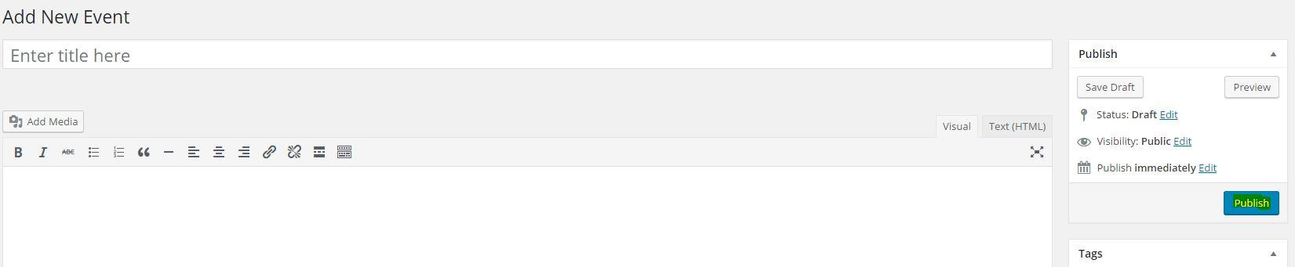

*Figure 1.8:* Publishing an event on website.

**Manage events:**

1- To manage events already made. Go to the “Events” main menu. Which will direct you to a table format of all the events currently in place as shown in figure 1.9.

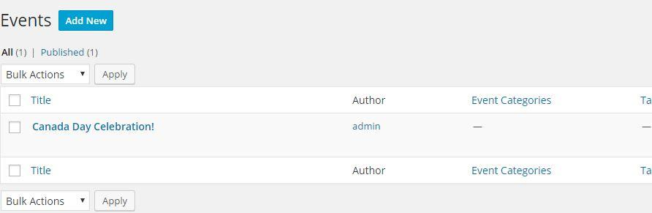

*Figure 1.9:* List of currently published events.

2- To delete one of the events in the table, hover the mouse on the event name, or if on a smartphone select the event name. And various text will appear. Select “Trash” to delete the event as shown in figure 1.10.

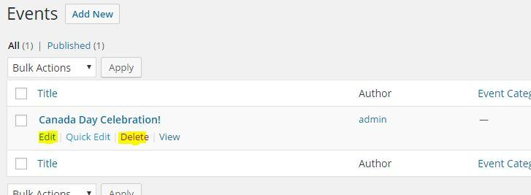

*Figure 1.10:* additional features for each event.

3- To update and make changes to an event, follow the same steps as directed in #2 above. However, select “edit” instead. Once directed to the event panel, update the fields and select complete to save the changes made.

1. **Add a video to page**

For the purpose of maintainability, we have opted to use embedding youtube videos as our method of adding videos to a page. In order to embed a video from YouTube, the video must first be available on youtube.

To upload a video to youtube is simple, in fact, follow the steps in this youtube video tutorial to upload a video! <https://www.youtube.com/watch?v=aHocQeo9ibY&feature=youtu.be>

1- Next, you’ll want to log in to WordPress, and find the page you want to add a video to by clicking on “Pages” in the dashboard as shown in figure 2.1.

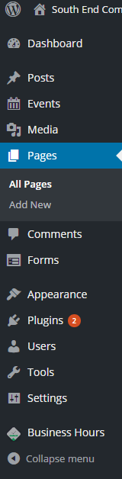

Figure 2.1:

2- When you’ve clicked pages you should be presented with a list of existing pages as shown in figure 2.2. Find the one you’d like to add a video to and hover your mouse over the page. You will get a list of options like the one in the figure below:  
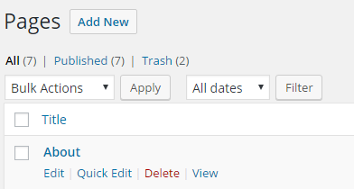  
  
figure 2.2:

3- Click “Edit” to edit the page. You should now see the page you’ve selected in the page editor as shown below figure 2.3:  
  
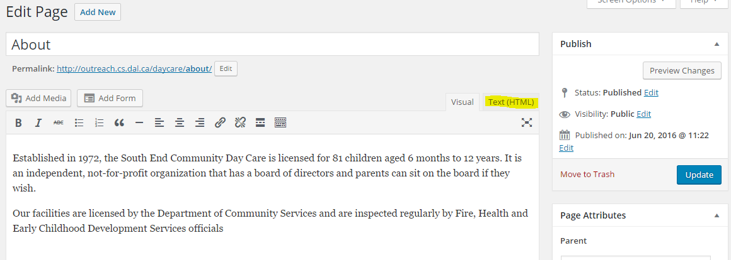  
figure 2.3:

4- Click on the tab “Text(HTML). You should now see the same content as shown in figure 2.4, but it might look a little less polished, that is OK.

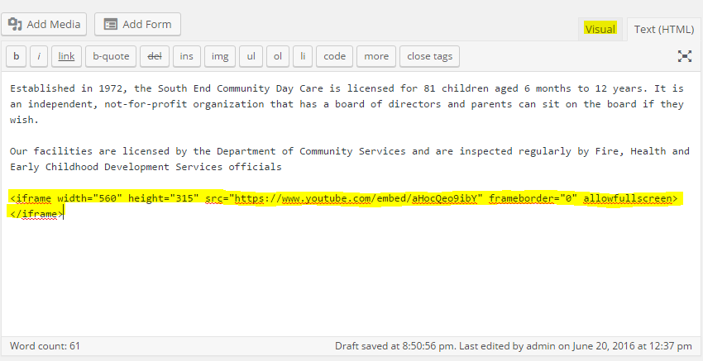

Figure 2.4:

5- In another window or browser tab, find the youtube video you’d like to add to your website as shown in figure 2.5.

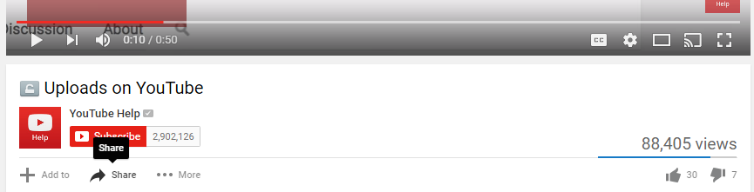

Figure 2.5:

6- Scroll to the bottom of the video and click “Share”. You should now see this menu similar to figure 2.6.



Figure 2.6:

7- Click on “Embed” and copy the highlighted section below in figure 2.7.

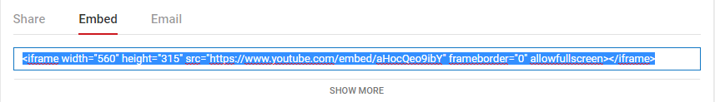

Figure 2.7:

8- Head back to your WordPress page and paste the contents where you’d like to see them in the page. An example is below figure 2.8:

Click the “Visual” tab in the editor to see a preview of the video in the page.



Figure 2.8: Setting position of video by embedding

If you are satisfied with the page, click “Save” to publish the content!

**Implementing Slider Images**

The slider image is the feature image that circulates through images on the main page of the website as seen in figure 1. Slider images are not constrained to only 2 and as many images can be uploaded to be used as a slider using this tutorial.



Figure 1 - Slider Image Example

A good rule of thumb for multiple slider images is to have the same dimensions for both or multiple slider images and for them to be at least 1600px wide and 200 px in height. The default dimensions of the current slider are: 1600px wide and 543px in height.

Px stands for pixel which is what online images are composed of. The recommendation allows for the slider to look uniform with the width of the layout.

Exceeding the recommended dimensions of the slider may cause the website to load slower and overshadow the layout. For example, if the slider image is too large such as 3000px in width and height it will make the page load much slower, especially for mobile users and will move the ‘About’ section lower onto the page.

The dimensions of an image can be seen by right-clicking on the image in your folder and selecting ‘Properties’ at the bottom of the menu as seen in Figure 2.

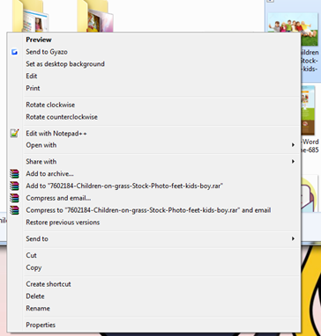

Figure 2 - Image properties

After which, navigating to the ‘Details’ tab will reveal the dimensions of the image as seen in Figure 3.

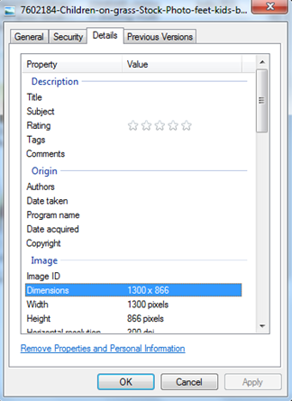

Figure 3 - Dimensions Tab

It is possible to crop and resize images to the suggested dimensions by downloading an image manipulation or graphic software such as Adobe Photoshop. Once an image is ready to be displayed as a slider, the user will navigate to the ‘Post’ tab and select ‘New Post’ on the left-sidebar of WordPress as seen in figure 4.

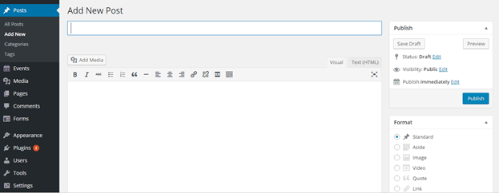

Figure 4 - Post Page

In order for the slider to be uploaded to the website it requires three components a slider title, feature image, and category. A category known as ‘Slider Post’ as seen in Figure 5 has already been created for the admin so it will not be necessary to create another one.

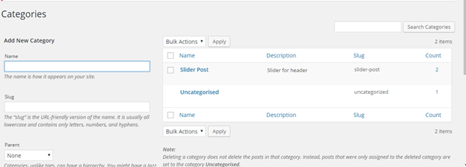

Figure 5 - Categories

The title as seen in Figure 6, is unimportant as it will not be revealed on the website but should be descriptive of the slider image for better organization.

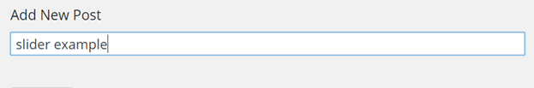

Figure 6 - Post Title

Once the title has been named and inputted into the field, the admin must scroll and check-mark the ‘Slider Post’ tag as seen in the Categories box on the right-hand bar of the Post page as seen in Figure 7.

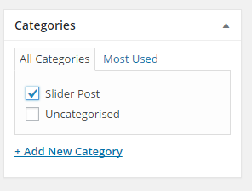  
Figure 7 - Categories Box

After which, it is time to upload the slider image under ‘Featured Image’ as seen in Figure 8, which can be seen two boxes down from the ‘Categories’ box. By clicking ‘set feature image’ a pop-up window will be revealed.

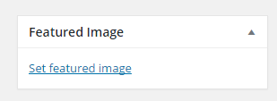

Figure 8 - Featured Image Box

The pop-up window will display two tabs on the top-left corner of the window. The first tab is the ‘Media Library’ which is a compilation of any images previously uploaded while using WordPress for the website as seen in Figure 9.

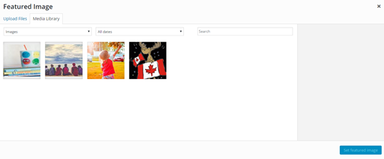

Figure 10 - Featured Image Gallery

To upload a new image, select the left-most tab ‘Upload Files’. This will open another new pop-up window as seen in Figure 10. Navigate to the directory of the slider image by navigating through the folders. Once the image has been found, select the image and click on ‘Open’.

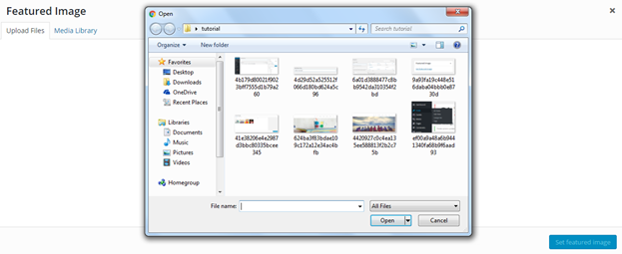

Figure 11 - Featured Image Upload

After which, click on the ‘Set Featured Image’ which is the blue button in the bottom right corner of the window also seen in Figure 11.

After the image has been set, a preview of the image will be revealed in the ‘Featured Image’ box as seen in Figure 12.

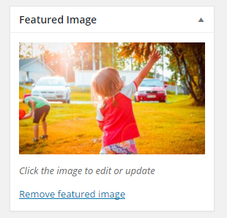  
Figure 12 - Featured Image

The last step is to publish the slider post by pressing the ‘Publish’ button which will be the first box on the right-hand side of the ‘Post’ screen as seen in Figure 13.

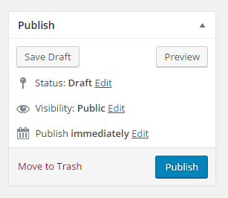

Figure 13 - Publish Table

Any time the admin wishes to upload another slider, perform the above steps with a new title name for each slider image. If the admin decides to later want to remove a slider image, click on the ‘Post’ tab again and it will reveal a compilation of all posts created. Hovering the mouse over the title of the slider they wish to remove will reveal a ‘delete’ text in red and clicking on it will delete the respective slider as seen in figure 14.

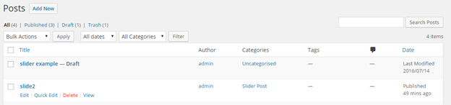  
Figure 14 - Posts Overview

**Troubleshooting technique**